**Problem Statement**

The global tech industry is evolving rapidly, with new languages, platforms, and tools emerging regularly. Understanding regional preferences and trends in technology usage is crucial for stakeholders to address skill gaps, improve training initiatives, and allocate resources effectively. This report investigates the skill_gap dataset to uncover trends and gaps in tech skills, focusing on languages, platforms, and databases across regions.

**Introduction**

The skill_gap dataset comprises individuals from diverse regions, providing a snapshot of their technological proficiencies. It includes data on languages, platforms, and databases that professionals have worked with or aspire to use. This analysis aims to identify:

* The most and least used languages by region.
* Platform preferences among professionals.
* Database usage trends.
* Insights into developers' preferred tools and languages. These insights will inform strategies for recruitment, training, and resource allocation, helping organizations and policymakers bridge skill gaps and foster innovation.

**Detailed Report**

**Language Analysis**

1. **Most Worked With Languages by Region**
   * Key languages such as HTML/CSS, Python, JavaScript, and SQL are widely used across regions.
   * Regional trends highlight the prominence of specific languages in particular areas, reflecting local industry demands.

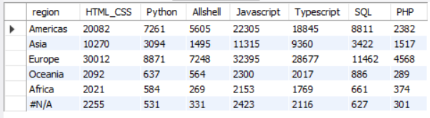

**Figure 1**: Table showing the most worked with languages by region.

1. **Most Desired Languages by Region**
   * Python and JavaScript emerge as the most desired languages, indicating their growing significance in modern tech roles.
   * A notable interest in TypeScript suggests a shift towards scalable and maintainable front-end solutions.

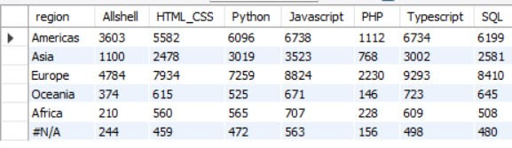

**Figure 2**: Visualization) of the most desired languages by region.

1. **People Working With 7+ Languages**
   * Regions with higher numbers of polyglot professionals demonstrate diverse technological landscapes and potential hubs of innovation.

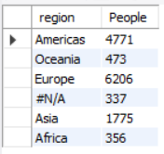

**Figure 3**: Regional distribution of professionals working with 7+ languages.

1. **Language Overlap Between Experience and Aspiration**
   * A significant number of professionals who have worked with HTML/CSS, Python, or JavaScript express interest in continuing to use these languages, underscoring their relevance.

**Figure 4**: Venn diagram or matrix showing overlap between worked with and desired languages.

**Platform Analysis**

1. **Most Used Platforms by Region**
   * Amazon Web Services (AWS) dominates as the preferred platform across regions, reflecting its widespread adoption in cloud computing.
   * Microsoft Azure also sees considerable usage, highlighting its role in enterprise environments.

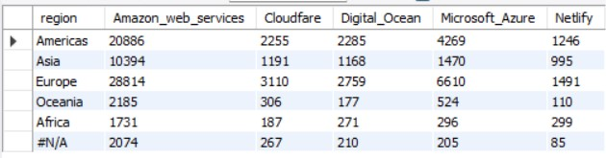

**Figure 5**: Chart depicting platform usage by region.

1. **Most Desired Platforms by Region**
   * The interest in platforms like Digital Ocean and Netlify signals a demand for specialized and developer-friendly hosting solutions.

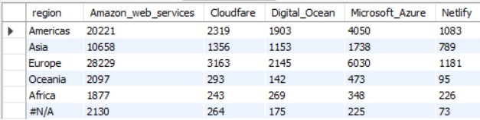

**Figure 6**: Chart illustrating platform preferences across regions.

1. **Cross-Analysis with Languages**
   * Professionals using AWS show a strong association with languages like Python and SQL, underlining their utility in cloud-based solutions.



**Figure 7**: Table showing language usage among AWS users.

**Database Analysis**

1. **Most Worked With Databases by Region**
   * PostgreSQL and MongoDB are prominent, showcasing their versatility and adoption for modern applications.
   * Microsoft SQL Server remains a staple for enterprise database management.

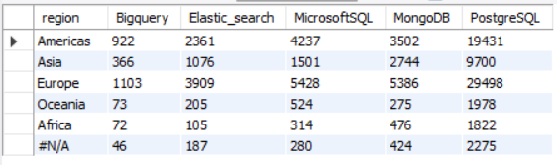

**Figure 8**: chart comparing database usage by region.

1. **Most Desired Databases by Region**
   * Emerging interest in Elasticsearch and PostgreSQL indicates trends towards robust search solutions and scalable databases.

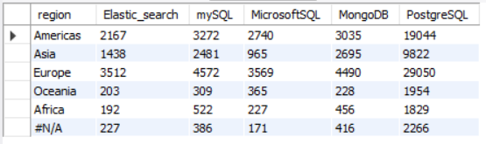

**Figure 9**: Chart highlighting desired databases across regions.

**Developer Insights**

1. **Languages Used by Developers**
   * Developers consistently favor Python and JavaScript, with a significant overlap in languages used and aspired to work with.

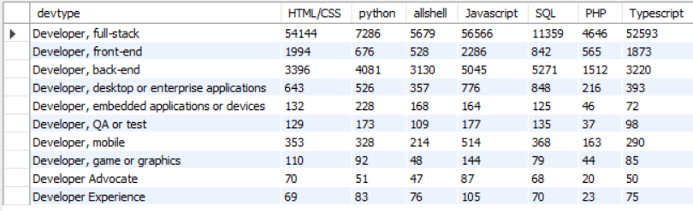

**Figure 10**: Developer language preferences by type.

1. **Tools Used by Developers**
   * Docker and NPM are among the top tools, reflecting their importance in development workflows and package management.

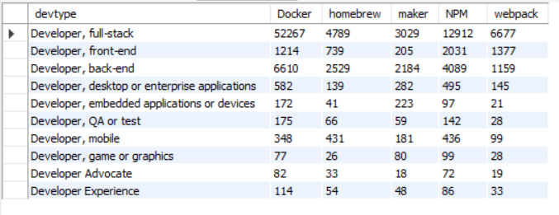

**Figure 11**: Chart or table showing tools used by developers.

**Conclusion**

This analysis highlights regional trends in tech skill usage and aspirations. Key findings include the dominance of AWS and PostgreSQL, the enduring relevance of Python and JavaScript, and the growing interest in scalable tools and platforms. These insights can guide efforts to address skill gaps, tailor training programs, and optimize resource distribution.

**Recommendations**

1. **Skill Development Initiatives**:
   * Launch targeted training programs focusing on high-demand languages like Python and JavaScript.
   * Provide specialized certifications for AWS and PostgreSQL to meet regional demands.
2. **Strategic Investments**:
   * Encourage adoption of emerging platforms like Digital Ocean and Elasticsearch in growth regions.
   * Support developer communities with tools like Docker to enhance productivity.
3. **Policy and Industry Collaboration**:
   * Facilitate partnerships between industry and academia to ensure curricula align with industry trends.
   * Promote cross-regional knowledge sharing to distribute expertise and address disparities in tech skills.